Generative AI and ChatGPT in Accounting Education :
A Scoping Review

Arif Rahman Hasdik¹, Nadya Annisa Nasruddin², Rafiqa Hastharita³
^{1,2,3}Accounting Education, Universitas Negeri Makassar, Indonesia
arif.rahman@unm.ac.id

Article Info |  | ABSTRACT
Article history:  Received September 11, 2026  Revised September 24, 2026  Accepted September 24, 2026  Published October 15, 2026 |  | The public release of ChatGPT in November 2022 accelerated the adoption of generative artificial intelligence (GenAI) in higher education, producing a fragmented but rapidly growing body of research on its role in accounting education. Individual studies have examined technology acceptance, academic integrity, assessment, and curriculum design, but no prior synthesis has mapped this evidence as a distinct field. This study aimed to map the scope, methodological characteristics, and thematic landscape of research on GenAI and ChatGPT in accounting education published between January 2022 and July 2026. A scoping review was conducted following the framework of Arksey and O'Malley, refined by Levac et al. and the Joanna Briggs Institute, and reported per the PRISMA-ScR guideline, with literature searched across Lens.org, ERIC, Google Scholar, and Scopus-indexed metadata and evidence synthesised thematically. From 149 records identified, 33 studies across 19 countries and 31 journals met the eligibility criteria, over four-fifths published in 2025-2026. The literature clustered into nine themes, led by technology acceptance (27.3%) and academic integrity and ethics (18.2%), and was dominated by quantitative survey designs (60.6%) grounded in technology-acceptance theories. Findings show GenAI research is shifting from adoption toward responsible educational integration, with GenAI functioning most productively as a cognitive scaffold rather than a substitute for accounting competence. The review concludes that accounting education should move from an adoption-centred model toward a responsible-integration model combining technology acceptance with assessment redesign, curriculum transformation, lecturer readiness, and protection of professional judgement, and proposes a research agenda emphasising longitudinal, comparative, and intervention-based studies.  Keywords: Accounting Education; ChatGPT; Generative Artificial Intelligence; Scoping Review; Technology Acceptance.
INTRODUCTION
The public release of ChatGPT in November 2022 marked a turning point in the adoption of generative artificial intelligence (GenAI) across higher education and professional practice. Students and educators now use it to generate text, analyse information, and solve problems, and the accounting profession is exploring it for financial reporting, data analysis, and decision support. In many accounting classrooms the question has shifted from whether GenAI should be used to how it can be integrated responsibly while protecting students’ professional competence, critical thinking, and academic integrity. In their critical essay, Ballantine et al. [1] argue that GenAI should not be treated as one more technology requiring incremental curriculum adjustment; it is an opportunity to reconsider the aims of accounting education and to strengthen critical thinking, ethical reasoning, and social awareness within the curriculum.
Empirical work has developed along several lines. Wood et al. [2] benchmarked ChatGPT on a large body of accounting assessment materials and found considerable capability on conceptual and scenario-based questions, strongest in accounting information systems and auditing and weaker in taxation and computation-intensive tasks; the study, however, assessed technical performance rather than teaching, curriculum, or learning. Dong et al. [3] conducted a scoping review of large language models in accounting and finance using Web of Science and SSRN, showing growth across auditing, financial reporting, asset pricing, and corporate finance, but education occupies only a small part of that synthesis. A synthesis devoted to accounting education as a distinct field is therefore still missing.
This gap is urgent for three reasons. First, the pace of change leaves little room for delay: benchmark evidence already shows that ChatGPT can answer a considerable share of conceptual and scenario-based accounting questions [2], which calls into question the validity of assessments that mainly reward reproducing correct answers, while assessment practices, curricula, and institutional policies change slowly. Second, consequential decisions on assessment rules, integrity policies, and graduate-competence expectations must be made on fragmented evidence scattered across accounting, education, business, and ethics journals, so educators cannot tell which questions are well studied, which rest on a single study, and which remain untouched. Third, the stakes are specific to accounting, where ethical reasoning, critical thinking, and professional judgement are central [1]: uncritical adoption may erode the competence and scepticism on which the profession relies, whereas blanket prohibition may leave graduates unprepared for practice environments in which intelligent systems are routine.
The novelty of this study lies in what existing work has not done. The essay by Ballantine et al. [1] is conceptual rather than a systematic account of empirical evidence; Wood et al. [2] benchmark model performance without examining teaching or learning; and the review by Dong et al. [3] addresses accounting and finance broadly and, published in 2024, predates most accounting-education research, the bulk of which appeared in 2025–2026 (Section 3.2). To the authors’ knowledge, this is the first scoping review devoted specifically to GenAI and ChatGPT in accounting education. It advances prior work by (i) searching four complementary sources through July 2026 so that recent evidence is captured; (ii) mapping the field along several dimensions at once, namely publication and geographic distribution, research design, theoretical grounding, and themes; and (iii) interpreting the evidence to propose a shift from an adoption-centred to a responsible-integration model of GenAI in accounting education, with a research agenda derived from the gaps identified.
Accordingly, this study aims to map the scope, methodological characteristics, and thematic landscape of research on GenAI and ChatGPT in accounting education published between January 2022 and July 2026, and to identify the gaps that should guide future research and the responsible integration of GenAI into accounting programmes.

METHOD
Review Design
A scoping review was chosen because research on GenAI in accounting education is exploratory and methodologically heterogeneous, spanning experiments, surveys, qualitative studies, conceptual papers, and reviews, and needs to be mapped before narrower systematic reviews or meta-analyses become feasible [3]. Unlike systematic reviews, which answer narrowly defined effectiveness questions, scoping reviews describe the breadth of evidence, clarify concepts, and highlight gaps [4]. The review followed the five-stage framework of Arksey and O’Malley [4]: identifying the research question, identifying relevant studies, selecting studies, charting the data, and collating and reporting the results. It was refined by Levac et al. [5] and by the Joanna Briggs Institute (JBI) guidance [6], which recommends the Population–Concept–Context (PCC) framework for eligibility criteria, and reported according to PRISMA-ScR [7], [8].
A protocol was prepared internally before the search; it was not formally registered, which PRISMA-ScR does not require [7], and no deviations occurred. Consistent with scoping-review methodology, no formal critical appraisal or risk-of-bias assessment was undertaken, because the purpose is to map the evidence rather than to judge the quality or effectiveness of individual studies [6].

Eligibility Criteria
Eligibility was defined with the PCC framework [6] (Table 1). The population comprised undergraduate and postgraduate accounting students, accounting educators and lecturers, curriculum developers, and higher education institutions offering accounting programmes; studies of professional accountants, auditors, or workplace training without a higher-education context were excluded. The concept was GenAI and large language models (ChatGPT, GPT-based applications, Gemini, Microsoft Copilot, Claude, LLaMA, and comparable systems) in terms of adoption, implementation, evaluation, perception, effectiveness, and educational implications; studies of AI in general, machine learning, expert systems, robotic process automation, or analytics without explicit discussion of GenAI were excluded. The context was higher-education accounting programmes, courses, and curricula; primary, secondary, vocational, corporate, and professional-practice settings without an educational focus were excluded. Only peer-reviewed journal articles and indexed conference proceedings in English, published between January 2022 and July 2026 with accessible full text, were eligible. The criteria were applied consistently at both the title-and-abstract and the full-text stages.

Table 1. Eligibility Criteria Based on the Population–Concept–Context (PCC) Framework
Component | Inclusion Criteria | Exclusion Criteria
Population | Undergraduate and postgraduate accounting students, accounting lecturers, educators, curriculum developers, and higher education institutions | Professional accountants, auditors, accounting firms, workplace training, continuing professional development without higher education context
Concept | Generative AI, ChatGPT, GPT, LLMs, Gemini, Copilot, Claude, LLaMA, educational use of GenAI | Artificial intelligence in general, machine learning, expert systems, robotics, predictive analytics without explicit discussion of generative AI
Context | Higher education accounting programmes, accounting courses, accounting curriculum, university teaching and learning | Primary education, secondary education, vocational schools, corporate training, professional practice without educational focus
Publication Period | January 2022 – July 2026 | Publications before 2022
Language | English | Non-English publications
Document Type | Peer-reviewed journal articles and indexed conference proceedings | Books, editorials, opinion papers, theses, dissertations, reports, magazine articles
Accessibility | Full-text available | Full text unavailable

Information Sources
Four complementary sources were searched: Lens.org (the primary multidisciplinary source), the Education Resources Information Center (ERIC), Google Scholar, and Scopus-indexed journal metadata accessed through the Watase UAKE discovery platform. Using several sources reduces database selection bias [6]. Lens.org yielded 35 journal articles and ERIC seven additional articles. Google Scholar initially returned 4,730 records (3,860 after year and language filters); consistent with recommendations for evidence reviews [9], only the first 100 ranked results were screened manually and compared with the Lens.org and ERIC records to identify further eligible studies and duplicates. The Scopus-indexed verification search, which targeted journals such as the Journal of Accounting Education, Journal of Education for Business, Journal of Emerging Technologies in Accounting, and Critical Perspectives on Accounting, added seven publications. All records were exported to Microsoft Excel for duplicate removal and screening.

Search Strategy
The search strategy was built on the PCC concepts [6]. Synonyms for GenAI (ChatGPT, large language model, LLM, GPT) were combined with OR and linked to accounting-education terms with AND, with exact phrases quoted where supported. Terms were derived iteratively from seminal publications [1]–[3] and refined through pilot searches to check relevance and precision. Syntax was adapted to each interface while keeping the concepts equivalent, and filters for year (January 2022–July 2026), language (English), and document type (peer-reviewed journal articles) were applied wherever available. The search strings and filters for each source are given in Table 2.
Table 2. Database Search Strategies
Information Source | Search Strategy | Filters Applied
Lens.org | ("generative AI" OR (ChatGPT OR ("large language model" OR (LLM OR GPT)))) AND Title: ("accounting education" OR ("accounting curriculum" OR ("accounting student" OR ("accounting program" OR "accounting course")))) | Journal articles; English; 2022–2026
ERIC | ("generative AI" OR "ChatGPT" OR "large language model" OR "LLM" OR "GPT") AND ("accounting education" OR "accounting curriculum" OR "accounting students" OR "accounting program" OR "accounting course") | Peer-reviewed journal articles; English; 2022–2026
Google Scholar | ("generative AI" OR "ChatGPT" OR "large language model") "accounting education" | English; 2022–2026; first 100 ranked records screened
Scopus-indexed journal metadata (via Watase UAKE) | ("generative AI" OR "ChatGPT" OR "large language model") AND ("accounting education" OR "accounting curriculum" OR "accounting students") | Recent Scopus-indexed journal articles

Study Selection Process
Records from all sources were combined in Microsoft Excel, and duplicates were removed by manual comparison of titles, authors, years, journals, and DOIs. Selection followed Arksey and O’Malley [4] as refined by Levac et al. [5], JBI [6], and PRISMA-ScR [7]. Screening had two stages. In title-and-abstract screening, records were retained if they investigated the use, implementation, evaluation, adoption, or educational impact of GenAI or LLMs in accounting education. The full texts of the remaining records were then assessed against all PCC criteria, with uncertain cases resolved at this stage. The most common exclusion reasons were the absence of an accounting-education context, a focus on professional practice rather than higher education, AI without a GenAI or LLM focus, ineligible document types, duplicates, and unavailable full texts. An audit trail of screening decisions and exclusion reasons was kept in Excel to support traceability [5], [6]. Screening was conducted by a single reviewer; iterative application of the criteria and full-text reassessment of uncertain records were used to improve consistency.
Of 149 records identified, 144 remained after five duplicates were removed, 35 full texts were assessed, and 33 studies met all criteria (Figure 1). Exclusion reasons and the screening matrix are provided in Appendix A.
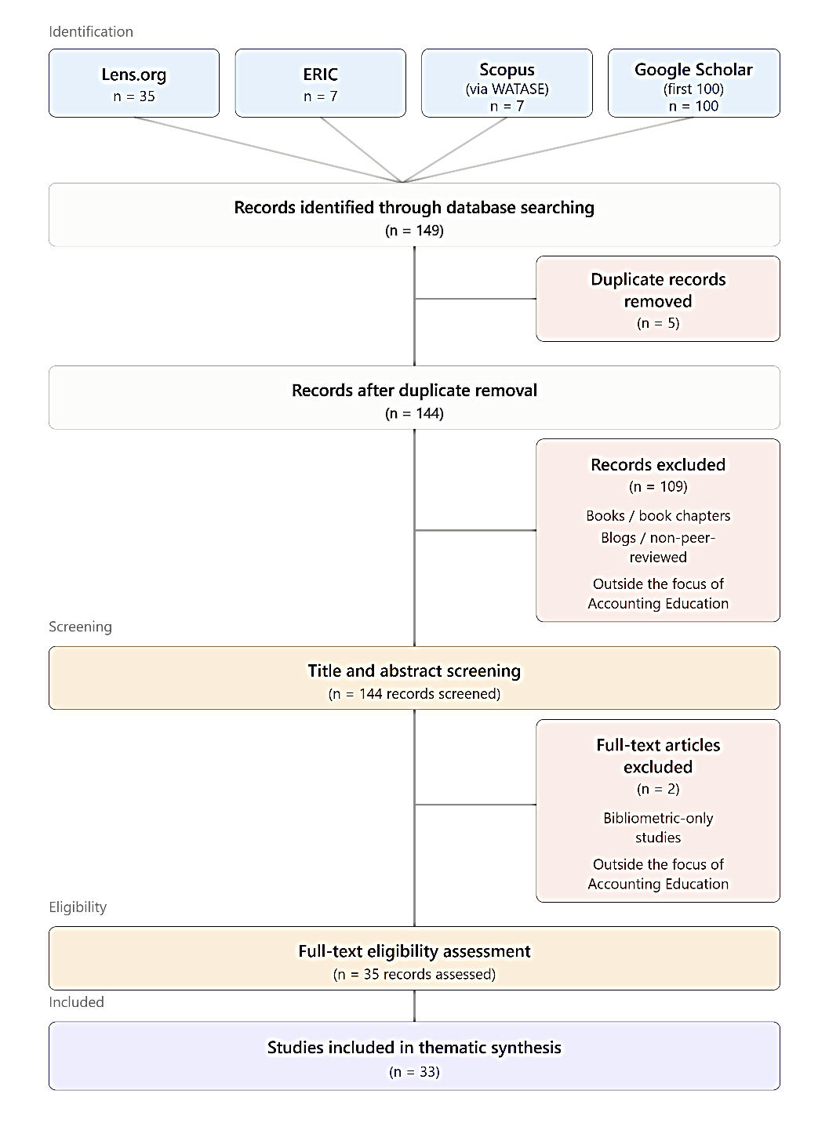
Figure 1. PRISMA-ScR Flow Diagram of the Study Selection Process

Data Charting
Data were charted with a standardised Microsoft Excel form developed for this review [10] and refined through a pilot extraction on several representative studies; the core variables did not change afterwards. Each article was read in full before coding. For every study the form captured bibliographic details, research design, participants, data collection, the GenAI tool examined, educational context and focus, principal findings, educational implications, and recommendations for future research (Table 3). The completed matrix for the 33 included studies (Appendix B) served as the evidence base for the synthesis.

Table 3. Data Charting Framework
Category | Variables Extracted | Purpose of Extraction
Bibliographic Information | Author(s), publication year, journal, country/institution, database source | Describe publication characteristics and research distribution
Study Characteristics | Research objectives, research design, participants, data collection methods | Identify methodological trends across studies
Generative AI Characteristics | Type of GenAI/LLM (ChatGPT, GPT-4, Gemini, Copilot, LLaMA, etc.) | Examine technological focus and evolution
Category | Variables Extracted | Purpose of Extraction
Educational Context | Accounting subject/course, educational level, learning environment | Describe the educational settings investigated
Research Themes | Curriculum, teaching and learning, assessment, academic integrity, technology acceptance, faculty adoption, professional judgement, student perceptions, digital competencies | Identify dominant thematic areas
Principal Findings | Main findings and educational implications | Compare evidence across studies
Future Research Directions | Research gaps and recommendations | Identify opportunities for future investigation

Synthesis of Evidence
The 33 studies were synthesised through inductive thematic synthesis [11], which suits the integration of quantitative, qualitative, mixed-methods, conceptual, and review evidence without pooling effect sizes. The synthesis had three stages: familiarisation with the evidence through repeated reading; initial descriptive coding of educational objectives, technology applications, learning outcomes, assessment practices, integrity, lecturer readiness, and implementation challenges; and grouping of similar codes into descriptive categories and themes through constant comparison, with themes emerging inductively rather than from a predetermined framework. Convergent findings were synthesised, and contradictory or unique findings were retained to show contextual variation. In keeping with scoping-review principles [4], [6], no quality appraisal or meta-analysis was undertaken.

RESULTS AND DISCUSSION
Characteristics of the Included Studies
The screening yielded 33 studies, both empirical and conceptual, from 19 countries and 31 journals. Their contexts range from student acceptance of ChatGPT (Malaysia, Indonesia), through assessment, skill development, and GenAI-supported learning (Australia, Saudi Arabia, Türkiye), to academic integrity and ethics (Jordan, Bangladesh, Malaysia, the United Kingdom, the United States) and curriculum and pedagogical innovation (India, Australia, the United Kingdom). Outlets are widely dispersed across accounting, education, business, and ethics journals: only the Journal of Applied Research in Higher Education and Asian Education and Development Studies contribute two studies each. The extraction matrix covering 16 variables per study is provided in Appendix B.

Publication Trends and Geographical Distribution
Research on GenAI in accounting education is very recent and expanding rapidly (Figure 2). Of the 33 studies, 1 (3.0%) was published in 2023, 5 (15.2%) in 2024, 10 (30.3%) in 2025, and 17 (51.5%) in 2026, so 27 of 33 (81.8%) appeared in the last two years of the review period.
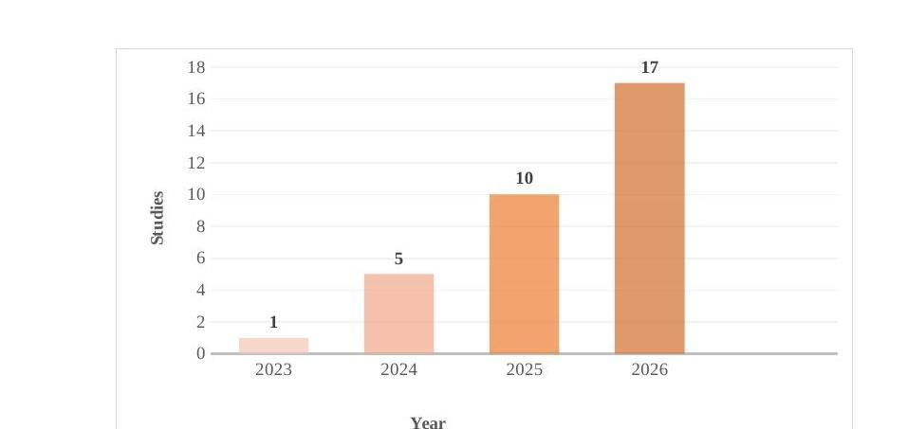
Figure 2. Annual Publication Trend of Included Studies (2023–2026)

The pattern suggests a move from exploratory to empirical work. The earliest contribution was conceptual: Ballantine, Boyce, and Stoner framed AI as a “change-inducing crisis” and called for accounting education to move beyond a purely technical curriculum [1]. Later work became more empirical and applied, including adoption surveys, experimental evaluations of LLM performance, classroom-based pedagogical studies, and mixed-methods work on curriculum transformation.
The geographical distribution, coded by the first author’s institutional affiliation, is broad but uneven (Figure 3). Indonesia contributed the most (7 studies; 21.2%), followed by Jordan (5; 15.2%) and the United States (3; 9.1%); Malaysia and Saudi Arabia contributed two studies each (6.1%), and the remaining 14 country categories one study each (3.0%). Indonesia and Jordan together account for almost two-fifths of the studies, so the literature is concentrated in Southeast Asia and the Middle East, and because most countries are represented by one or two studies, strong cross-country generalisations are not yet supported.

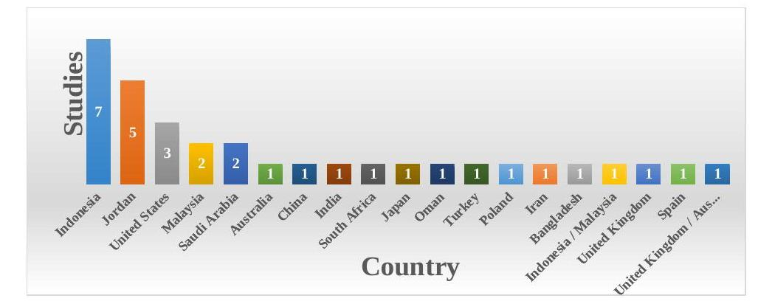
Figure 3. Geographical Distribution of Included Studies
(Based on First Author Affiliation)

Methodological and Theoretical Characteristics
Research remains dominated by quantitative empirical work: 20 of the 33 studies (60.6%) (Figure 4). The most common design is the quantitative survey (15 studies; 45.5%), followed by cross-sectional surveys (2; 6.1%) and single studies using explanatory, cross-sectional survey, and moderated-regression designs. These studies model behavioural intention, adoption, competence, academic performance, and perceived learning outcomes. Qualitative research accounts for four studies (12.1%), all case studies, which reveal what surveys capture poorly: digital competence, infrastructure, and teacher autonomy in South Africa, and overreliance, information accuracy, and responsible use among Malaysian and Indonesian students. Six studies (18.2%) are experimental or design-based, including LLM performance studies on accounting assessments and cases (Australia, the United States, Spain), a lightweight GenAI model design (China), and an experiment on ChatGPT advice and professional judgement (Japan). One study (3.0%) used mixed methods and two (6.1%) are conceptual or review papers. The scarcity of mixed-methods work suggests that explanatory modelling has not yet been balanced with rich qualitative interpretation.
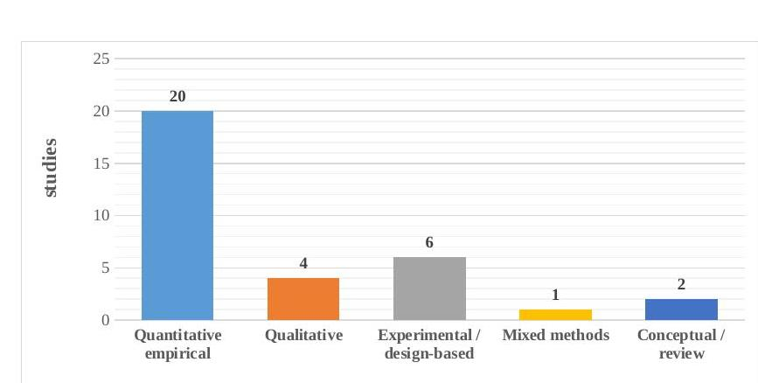
Figure 4. Distribution of Research Designs

The theoretical profile is shown in Figure 5. Twelve studies (36.4%) belong to the technology acceptance and adoption family (TAM, extended TAM, UTAUT, UTAUT2, TPB, and hybrids); six (18.2%) to the ethical and behavioural judgement family (Fraud Triangle Theory, Attribution Theory, ethical orientation, moral judgement); six (18.2%) to the pedagogical and learning-design family (TPACK, constructivist and reflective-thinking perspectives, revised Bloom’s taxonomy, SDT with ICAP, critical accounting education); and nine (27.3%) did not state a theoretical framework, being conceptual, descriptive, benchmarking, or applied studies. The field is thus anchored in behavioural adoption theory but is broadening toward pedagogical and ethical frameworks, and greater theoretical coherence is needed so that findings can accumulate.
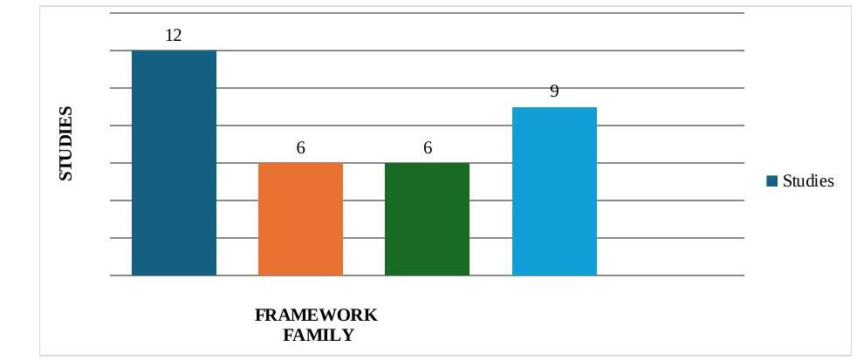
Figure 5. Distribution of Theoretical Frameworks
Thematic Synthesis
The 33 studies were classified by their dominant focus (Figure 6). The literature clusters around technology acceptance, academic integrity and ethics, assessment and skill development, learning effectiveness, curriculum development, teaching and learning innovation, lecturer readiness, professional judgement, and student perceptions. The profile shows that the field has moved beyond asking whether students and lecturers will adopt tools such as ChatGPT toward learning design, ethical conduct, assessment quality, and professional competence.
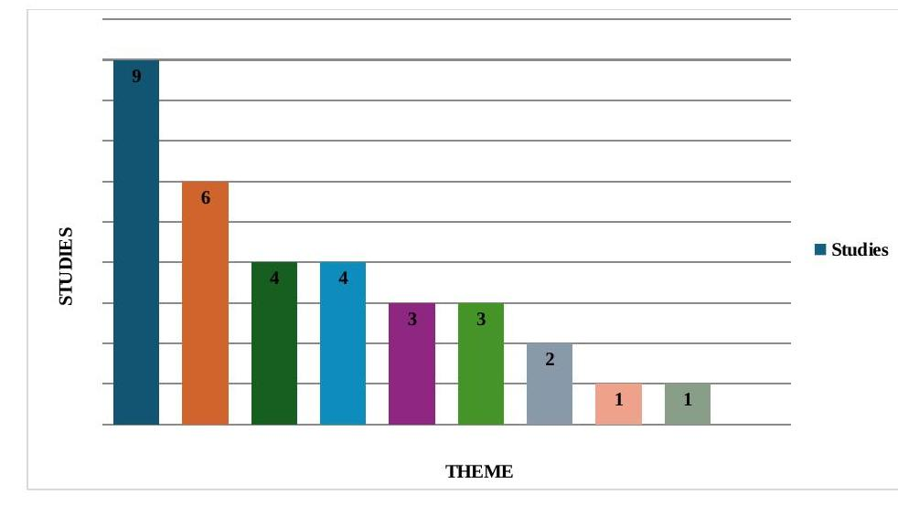
Figure 6. Distribution of Research Themes

- Technology Acceptance
Technology acceptance is the largest cluster, with 9 of the 33 studies (27.3%). These theory-driven, mostly quantitative studies ask which conditions make GenAI adoption more likely and sustained [12]. Perceived usefulness and ease of use recur: in the Malaysian TAM study, intention to use ChatGPT was associated with both, as well as result demonstrability and technological self-efficacy, and the Indonesian TAM extension found that trust and social influence also raised intention. Contextual and social determinants matter too: Jordanian studies found usage and continuance shaped by COVID-19 concerns, protection motivation, peer influence, and perceived fear; the Indonesian extended-UTAUT2 study found that performance expectancy and habit drove intention, while intention, facilitating conditions, and habit predicted use; and the Polish study showed that habit, social influence, and facilitating conditions shaped use, mainly for self-study, projects, and homework. Disciplinary knowledge and trust also enter the models: in the Omani study accounting knowledge strengthened the effects of attitude and perceived behavioural control on adoption. Together, the studies portray acceptance as a multi-layered process in which usefulness and ease of use are reinforced or weakened by habit, social influence, and facilitating conditions, and in which adoption becomes more responsible when students have disciplinary knowledge, trust the tool, and receive institutional support. The evidence is mostly cross-sectional and self-reported (SEM or PLS-SEM), so it explains intention better than long-term classroom integration; adoption over time, across institutions, and across curricula needs study.
- Academic Integrity & Ethics
Academic integrity and ethics is the second-largest theme, with 6 of the 33 studies (18.2%). Where acceptance studies ask why students adopt GenAI, these ask what happens when its use threatens honesty, responsibility, or fair assessment [13]. Students and educators are highly aware of risks such as overdependence, plagiarism, research fraud, biased outputs, and weakened critical thinking. Three patterns emerge. First, usefulness and ethical concern coexist: the Indonesian study on whether ChatGPT is “good” for accounting students found effects on views, procrastination, memory loss, ethical perceptions, and critical thinking, with role clarity reducing some negative effects [14]. Second, Fraud Triangle Theory explains misuse well: the Jordanian study identified opportunity, rationalisation, and pressure as determinants of dishonesty, the Iranian study linked motivation, opportunity, and justification to research fraud, and the Bangladeshi study found that opportunity and pressure increase dishonesty, with academic support moderating the effects of pressure and rationalisation. Third, students and educators call for policy and literacy: Malaysian students used LLMs to draft assignments, clarify concepts, and solve tutorial questions but feared dishonesty and overdependence, while UK educators saw misconduct, overreliance, inaccuracy, bias, and privacy concerns and recommended clear policies, AI literacy training, and assessment that promotes higher-order thinking. The studies thus favour ethical guidance, institutional support, assessment reform, and AI literacy over simple prohibition. Most are descriptive or cross-sectional and say little about whether such measures reduce misuse, so future research should test concrete interventions and their effect on misconduct and educational benefit.
- Assessment & Skill Development
Four studies evaluated how well GenAI performs accounting tasks. The Australian study assessed ChatGPT across six accounting courses and 18 assessments aligned with the revised Bloom’s taxonomy and found it more effective for lower- to mid-order tasks than higher-order ones. In the U.S. financial accounting study, three leading LLMs achieved near-perfect performance on structured tasks and exceeded the student average in final course performance, but struggled with the multi-step Jackson Cycle project. The Spanish study found strong performance on theoretical questions, less consistent performance on journal entries, and less reliable performance on financial statement preparation; prompting strategies had mixed effects, more advanced reasoning versions improved performance more clearly, and in a pilot class LLM-supported income statement preparation matched instructor-supported performance. A second U.S. study evaluated ChatGPT 3.5 and 4 on seven educational accounting cases and found stronger performance on explanation, rule application, and ethical evaluation than on financial statement creation, journal entries, and software use; it also reported that AI-text detection tools were ineffective. GenAI is thus strongest in foundational knowledge, structured question answering, and theoretical explanation, and weaker in journal entries, statement preparation, multi-step reasoning, and complex judgement. Its educational value lies in helping educators redesign assessment so that tasks match the cognitive level they intend to measure, since detection tools cannot secure it. Most studies are single-course, short-term, or task-specific, so evidence on long-term assessment reform and learning progression is thin.
- Learning Effectiveness
Four studies examined whether GenAI is associated with improved competence, motivation, reflective thinking, sustainability judgement, or perceived performance [15]. The Indonesian competence study found that ChatGPT positively and significantly influenced student competence, especially in analysing and understanding accounting concepts, while cautioning that careless use may reduce critical thinking. The Saudi study found GenAI-supported learning positively associated with perceived critical thinking and sustainability knowledge, which in turn were related to perceived sustainability judgement capability, with AI literacy strengthening these relationships. The Indonesian–Malaysian study (222 respondents) found that AI and lecturer creativity enhanced reflective thinking and perceived learning outcomes, with lecturer creativity having the stronger direct effect. A study of student perceptions found ChatGPT integration positively associated with self-reported motivation and perceived academic performance, with motivation partially mediating the relationship, although these are perceptions rather than objective learning gains. The evidence is encouraging but provisional. GenAI can support learning when it fosters conceptual understanding, critical thinking, and reflection, but effects depend on AI literacy, lecturer creativity, and structured design, and reliance on perceived, cross-sectional, self-reported outcomes limits causal claims. Experimental, longitudinal, and mixed-methods work is needed.
- Curriculum Development
Three studies (9.1%) treat GenAI as a question of what accounting curricula should teach. The critical essay by Ballantine, Boyce, and Stoner frames GenAI as a “change-inducing crisis” that exposes a curriculum long dominated by technical, managerial, and financial priorities and calls for recovering the human dimension of accounting. The TPACK-based “lightweight” GenAI model for Fundamental Accounting argues that instruction is constrained by reliance on specialised software and high adoption barriers, and proposes general-purpose GenAI as a low-threshold foundation within an Environment–Content–Process–Evaluation framework. The applied mixed-methods study on metaverse-enabled AI and LLMs found that technological and pedagogical integration were positively associated with learning outcomes, mediated by skill development, practical application, engagement, and knowledge retention, with institutional readiness, faculty capability, and pedagogical alignment as critical success factors. Curriculum reform is thus not a matter of inserting ChatGPT into existing materials: curricula must accommodate AI literacy, prompt design, and critical evaluation of AI output while preserving the human, ethical, and reflective dimensions of accounting education. The cluster is small and partly conceptual, so it proposes transformation more than it demonstrates implementation.
- Teaching & Learning Innovation
Three studies (9.1%) examine how GenAI can redesign classroom practice. The digital role-play gamification paper proposes GenAI-powered role-playing games that simulate real-world scenarios and give individualised feedback through AI-driven characters. The Turkish cost-accounting case study instructed ChatGPT to generate a case aligned with course learning outcomes, found its responses effective, and stressed that cost accounting extends beyond numbers to critical thinking, ethical reasoning, and empathy, so GenAI enriches case-based teaching rather than replacing the instructor. The Indonesian qualitative study found strong benefits in efficiency and accessibility of information but also concerns about accuracy and overreliance. Innovation is thus moving toward interactive, immersive, and adaptive practice, most effective when built around learning outcomes and when it still requires active student thinking. The evidence is small-scale and exploratory, so comparative classroom studies are needed to show which innovations work best.
- Lecturer Readiness
Lecturer readiness, represented by two studies, addresses how prepared accounting educators are and what institutional conditions support meaningful use [16]. The South African case study, based on interviews with five accounting teachers and framed by UTAUT, reports concerns about digital and pedagogical competencies, inadequate digital infrastructure, social inequality among learners, diminished teacher autonomy, and employment threats, showing that readiness depends on both individual capability and system-level conditions. The Indonesian–Malaysian survey recommended structured AI training for lecturers, AI-assisted journaling, and self-assessment. Readiness is therefore multidimensional, combining digital competence, pedagogical creativity, and institutional support, and GenAI integration depends on the preparedness of the educators who design, mediate, and evaluate learning. The evidence is limited and says little about how training, policy, workload, and infrastructure change teaching practice.
- Professional Judgment
Professional judgement is the most narrowly represented theme but links GenAI directly to a core accounting competency. In a Japanese experiment [17], accounting majors acting as proxies for financial controllers received GenAI advice, human auditor advice, or no advice. Advice from GenAI, like advice from a human auditor, increased the likelihood of deontological judgement compared with no advice, and participants with higher algorithm appreciation, greater familiarity with consolidated accounting standards, or completed internships at accounting firms were more likely to judge deontologically, even when exposed to consequentialist advice. GenAI can therefore nudge ethical reasoning without eliminating the role of accounting knowledge and experience, so professional judgement should be treated as a competency enhanced, not substituted, by GenAI. Because the evidence rests on a single experiment, other cultural and educational settings need testing.
- Overall Thematic Synthesis
Taken together, the synthesis shows GenAI conceptualised less as a technological novelty than as a transformative educational phenomenon touching adoption, teaching and learning, curriculum, assessment, integrity, professional judgement, and institutional readiness. Technology acceptance remains the dominant entry point, but recent studies increasingly examine educational consequences. Academic integrity is a defining challenge that extends beyond plagiarism to overreliance, research misconduct, and weakened critical thinking, and most studies favour AI literacy, assessment redesign, policy, and ethical guidance over restriction. GenAI performs well on structured and foundational tasks but less well on complex judgement and multi-step reasoning, and reported learning gains are mediated by instructional design, AI literacy, and lecturer expertise. Four gaps remain: most studies are cross-sectional surveys that explain intention better than long-term impact; few examine sustained, programme-wide implementation; the evidence is concentrated in a few countries, particularly Indonesia and Jordan; and behavioural theories outweigh pedagogical, curriculum, or professional-competence frameworks.

Discussion
Overview of the Main Findings
This review mapped 33 studies from 19 countries and 31 journals, more than four-fifths of them published in 2025–2026, which indicates a field still in an early developmental phase. Three conclusions emerge. First, technology acceptance remains the main entry point, with perceived usefulness, ease of use, trust, social influence, facilitating conditions, habit, and accounting knowledge repeatedly identified as determinants of adoption. Second, attention is shifting from whether GenAI will be used to what happens educationally after adoption. Third, the educational value of GenAI is conditional rather than automatic: it depends on task characteristics, AI literacy, lecturer mediation, assessment design, institutional policy, and students’ responsibility for their own reasoning. Because 20 of the 33 studies are quantitative and mostly survey-based, the literature explains adoption better than durable learning effects, programme-level implementation, or changes in professional competence.

From Technology Acceptance to Responsible Educational Integration
Studies using TAM, UTAUT, UTAUT2, TPB, and hybrid models converge: students use GenAI more readily when it is useful, easy to use, trustworthy, and socially and institutionally supported [18]–[22]. Acceptance, however, should not be the endpoint of analysis, because a high intention to use GenAI can coexist with weak disciplinary knowledge or inappropriate delegation of cognitive work. That accounting knowledge strengthens responsible adoption [23] suggests that domain competence acts as an interpretive control, letting students verify and contextualise AI output. The review therefore supports a move from an adoption-centred model, whose outcomes are intention and actual use, to a responsible-integration model in which adoption is tied to educational purpose, ethical boundaries, verification, and learning responsibility. This also reconciles positive adoption findings with ethical concerns: a tool can be easy and useful and still require strong governance.

GenAI as a Cognitive Scaffold and Assessment Redesign
GenAI is most productive as a cognitive scaffold rather than a substitute for accounting competence. The reviewed studies report relatively strong performance on structured questions and conceptual explanations but less reliable performance on multi-step reasoning, journal entries, financial statement preparation, and complex judgement [24]–[27], and learning benefits appear more plausible when GenAI is paired with conceptual understanding, critical reflection, AI literacy, and purposeful design [28]–[30]. At lower cognitive levels GenAI can provide explanations, examples, and formative feedback; at higher levels it should become an object of critique and verification rather than a substitute for the student’s judgement, consistent with the Bloom-oriented findings of Tharapos et al. [27].
Because GenAI can achieve near-perfect performance on routine, rule-based assessments, assessments that mainly reward reproduction are hard to defend as evidence of competence; the issue is the alignment between an assessment and the competence it claims to measure. Authentic designs that make reasoning visible, such as oral defences, reflective commentaries, process portfolios, source-verification logs, and tasks requiring students to critique an AI-generated solution, reposition rather than prohibit GenAI [31], [32]. Detection is a weak alternative, since AI-text detectors may fail to identify generated output [24]; assessment security should instead be built upstream through task design, process evidence, and transparent rules on permitted AI use.

Academic Integrity, Ethics, and Institutional Governance
Plagiarism, overdependence, dishonesty, research fraud, bias, and weakened critical engagement recur as risks [33]–[37], yet misconduct is not explained by technology alone: Fraud Triangle studies identify opportunity, pressure, and rationalisation as determinants, with academic support moderating some relationships [33]–[35]. If assessments reward output rather than reasoning, or expectations are unclear, misuse cannot be treated solely as a problem of student character, and students themselves ask for clearer rules [36], [38]. The evidence therefore favours layered governance over blanket prohibition: lecturers should specify permitted uses and require disclosure where appropriate; programmes should build AI literacy and verification skills progressively; and institutions should set policy on integrity, privacy, data protection, intellectual property, and accountability.

Curriculum, Pedagogical Innovation, and Lecturer Readiness
Curriculum studies show GenAI blurring the boundary between technical accounting knowledge and broader professional capabilities: Ballantine et al. [1] frame AI as a catalyst for reconsidering the purpose of accounting education, Fang [39] proposes a lightweight GenAI teaching architecture, and Abhishek et al. [40] link AI integration to workforce-oriented curriculum change. A responsive curriculum would retain core accounting knowledge while adding prompt formulation, output verification, source evaluation, ethical reasoning, and digital scepticism, progressing from basic AI literacy, to guided use in problem solving, to complex cases in which students challenge AI recommendations and defend their own judgements. In the classroom, GenAI supports case generation, role-play, and personalised feedback [31], [32], [41], but these innovations work best when driven by learning outcomes and accompanied by verification and reflection requirements; pedagogical novelty should not be equated with effectiveness.
Integration also depends on lecturers. Readiness spans digital competence, pedagogical confidence, creativity, workload, infrastructure, and institutional support [42], [30], so eager students may be paired with lecturers who lack the time, guidance, or resources to redesign assessment. Faculty development should therefore go beyond tool demonstrations to cover prompt design, source verification, assessment redesign, integrity scenarios, and awareness of bias and hallucination.

Professional Judgement and Human Oversight
The professional-judgement evidence is narrow but conceptually significant. Sugahara and Kano [17] show that ChatGPT advice can influence accounting students’ ethical judgement in a direction comparable to human auditor advice, and that accounting knowledge, internship experience, and algorithm appreciation shape how the advice is interpreted. GenAI thus becomes a behavioural input to professional reasoning rather than a replacement for it, and professional scepticism is likely to become more, not less, important. Professional judgement should be treated as a protected learning outcome, with GenAI used to offer alternative reasoning or challenge a student’s initial position while the student remains the accountable evaluator.

Theoretical Contributions and Implications
The review makes three theoretical contributions. First, it confirms the explanatory value of technology-acceptance theories while showing their limits when the outcome extends beyond behavioural intention. Second, it supports integrating behavioural theories (TAM, UTAUT, TPB), which explain why students adopt GenAI, with pedagogical frameworks (TPACK, constructivist and reflective-thinking perspectives, Bloom-oriented assessment), which explain what educators can do after adoption, so that a pathway from enabling conditions to adoption, learning processes, and professional outcomes can be modelled. Third, it highlights the need for a socio-technical, governance-oriented perspective in which institutional support, academic ethics, lecturer creativity, assessment design, and disciplinary knowledge co-produce outcomes.
For educators, the implication is to redesign learning activities rather than appendsGenAI instructions, requiring verification and reflection for consequential tasks and giving greater weight to analysis, evaluation, and process-based evidence. For curriculum leaders, AI literacy should be embedded longitudinally within accounting content. For policymakers, governance should distinguish permitted assistance, restricted use, and prohibited substitution of student work, define disclosure expectations, and be backed by investment in professional development. For professional bodies and accreditors, AI capability should be treated as a professional competence combining tool use with verification, ethics, communication, and judgement, with accountability remaining with the graduate.

Research Agenda
The evidence points to six research priorities: (1) longitudinal designs that track GenAI use across semesters and relate it to later competence; (2) objective outcome measures, such as validated assessments, rubric-based performance, and retention tests, in place of self-reports; (3) intervention studies that test assessment redesign and AI-literacy programmes; (4) comparative cross-country research, since Indonesia and Jordan supply a disproportionate share of the evidence; (5) joint study of lecturers and students within the same institution; and (6) expanded professional-judgement research, which rests on a single experiment and would benefit from designs comparing human, AI, combined, and no advice.

Limitations of the Present Review
Four limitations should be noted. First, the evidence base depends on the sources and search strategy used, so studies outside Lens.org, ERIC, Google Scholar, and Scopus-indexed journals, or with inaccessible full texts, may have been missed. Second, the review was conducted by a single reviewer without independent duplicate screening; the audit trail and full-text reassessment improved consistency but do not remove this limitation. Third, no formal risk-of-bias assessment was conducted, consistent with the mapping purpose of a scoping review, so studies were not weighted by methodological quality. Fourth, because GenAI research is published rapidly, later evidence may alter the thematic distribution; the findings are a structured map of the defined review window, not a permanent description of the field.

CONCLUSION
GenAI is reshaping accounting education through a transition from adoption toward responsible integration. The evidence shows that GenAI offers substantial support for structured and foundational tasks; that its benefits become more plausible when combined with AI literacy, lecturer creativity, and purposeful learning design; that assessment must measure reasoning and process rather than routine output; that academic integrity requires governance and redesign rather than detection alone; that the curriculum should combine AI capability with accounting expertise, ethics, and scepticism; and that professional judgement must remain a human-accountable competence. Accounting education therefore need not choose between embracing and resisting GenAI: the evidence favours selective, transparent, and pedagogically purposeful integration, supported by longitudinal, experimental, comparative, and institutionally grounded research.

BIBLIOGRAPHY
[1] J. Ballantine, G. Boyce, and G. Stoner, “A critical review of AI in accounting education: Threat and opportunity,” Critical Perspectives on Accounting, vol. 99, no. 1, p. 102711, 2024, doi: 10.1016/j.cpa.2024.102711.
[2] D. A. Wood, M. P. Achhpilia, M. T. Adams, S. Aghazadeh, and E. D. Almer, “The ChatGPT artificial intelligence chatbot: How well does it answer accounting assessment questions?,” Issues in Accounting Education, vol. 38, no. 4, pp. 81–108, 2023, doi: 10.2308/ISSUES-2023-013.
[3] X. Dong, T. C. Stratopoulos, and C. Wang, “A scoping review of ChatGPT research in accounting and finance,” International Journal of Accounting Information Systems, vol. 55, p. 100715, 2024, doi: 10.1016/j.accinf.2024.100715.
[4] H. Arksey and L. O’Malley, “Scoping studies: Towards a methodological framework,” Int. J. Soc. Res. Methodol., vol. 8, no. 1, pp. 19–32, 2005, doi: 10.1080/1364557032000119616.
[5] D. Levac, H. Colquhoun, and K. K. O’Brien, “Scoping studies: Advancing the methodology,” Implementation Science, vol. 5, p. 69, 2010, doi: 10.1186/1748-5908-5-69.
[6] M. D. J. Peters and others, JBI manual for evidence synthesis. Joanna Briggs Institute, 2024. doi: 10.46658/JBIMES-24-01.
[7] A. C. Tricco and others, “PRISMA extension for scoping reviews (PRISMA-ScR): Checklist and explanation,” Ann. Intern. Med., vol. 169, no. 7, pp. 467–473, 2018, doi: 10.7326/M18-0850.
[8] M. J. Page and others, “The PRISMA 2020 statement: An updated guideline for reporting systematic reviews,” BMJ, vol. 372, p. n71, 2021, doi: 10.1136/bmj.n71.
[9] N. R. Haddaway, A. M. Collins, D. Coughlin, and S. Kirk, “The role of Google Scholar in evidence reviews and its applicability to grey literature searching,” PLoS One, vol. 10, no. 9, p. e0138237, 2015, doi: 10.1371/journal.pone.0138237.
[10] D. Pollock and others, “Recommendations for the extraction, analysis, and presentation of results in scoping reviews,” JBI Evid. Synth., vol. 21, no. 3, pp. 520–532, 2023, doi: 10.11124/JBIES-22-00123.
[11] J. Thomas and A. Harden, “Methods for the thematic synthesis of qualitative research in systematic reviews,” BMC Med. Res. Methodol., vol. 8, p. 45, 2008, doi: 10.1186/1471-2288-8-45.
[12] N. C. Hidajat, F. N. Kosasih, S. Sundari, and K. Kartini, “Factors influencing accounting students’ intentions to use generative AI (ChatGPT),” Advances: Jurnal Ekonomi & Bisnis, vol. 4, no. 3, pp. 642–661, 2026, doi: 10.60079/ajeb.v4i3.843.
[13] K. O. Josephine, T. M. Tarigan, and W. Weli, “Large language models in accounting tasks: Driving factors and ethical dilemmas among accounting students,” Jurnal Sisfokom, vol. 15, no. 1, 2025, doi: 10.32736/sisfokom.v15i01.2531.
[14] K. Fikrianoor, W. Nurpatwikanto, and F. Rakhman, “Chat GPT usage: Is it good for accounting students?,” Jurnal Akuntansi Multiparadigma, vol. 15, no. 3, pp. 588–598, 2024, doi: 10.21776/ub.jamal.2024.15.3.41.
[15] A. Rahmat and Sriwidharmanely, “The effect of ChatGPT use on academic performance of accounting students: The moderating role of ethical orientation,” Review of Applied Accounting Research, vol. 5, no. 2, pp. 1–20, 2025, doi: 10.30595/raar.v5i2.27407.
[16] F. T. Haidar and M. A. Alyousef, “Investigating behavioral and technical factors influencing faculty adoption of ChatGPT in accounting education,” Discover Education, vol. 5, p. 318, 2026, doi: 10.1007/s44217-026-01309-z.
[17] S. Sugahara and K. Kano, “The impact of ChatGPT’s advice on professional judgment related with accounting and the role of accounting education,” Journal of Business Ethics, 2026, doi: 10.1007/s10551-026-06365-x.
[18] T.-H. Lee, “Influential factors of accounting students’ intentions to use ChatGPT,” International Journal of Academic Research in Accounting, Finance and Management Sciences, vol. 16, no. 2, pp. 21–42, 2026, doi: 10.6007/IJARAFMS/v16-i2/28057.
[19] M. Al-Okaily, “ChatGPT as an educational resource for accounting students: Expanding the classical TAM model,” Educ. Inf. Technol. (Dordr)., 2025, doi: 10.1007/s10639-025-13391-1.
[20] M. Al-Okaily, “Implementation of generative AI tools in accounting education context,” Journal of Applied Research in Higher Education, 2025, doi: 10.1108/JARHE-08-2024-0422.
[21] E. W. Maruszewska, E. W. Ziemba, D. Grabara, and K. Renik, “The determinants of ChatGPT usage among accounting students: The role of habit, social influence and facilitating conditions,” Zeszyty Teoretyczne Rachunkowości, vol. 48, no. 3, pp. 215–232, 2024, doi: 10.5604/01.3001.0054.7264.
[22] R. Setiyani, J. T. B. Santoso, A. Nurkhin, and S. Fatimah, “Study of ChatGPT utilization behavior by accounting education students: Extended UTAUT2 model perspective,” Jurnal Pendidikan Ekonomi dan Bisnis, vol. 13, no. 1, 2025, doi: 10.21009/JPEB.013.1.6.
[23] S. A. Bin-Nashwan, N. Alyafai, A. E. A. A. Ismaiel, and M. M. Ma’aji, “Accounting knowledge as a compass in ChatGPT adoption among accounting students in higher educational institutions,” Journal of Information, Communication and Ethics in Society, 2026, doi: 10.1108/JICES-09-2025-0235.
[24] X. Cheng and others, “Artificial intelligence’s capabilities, limitations, and impact on accounting education: Investigating ChatGPT’s performance on educational accounting cases,” Issues in Accounting Education, vol. 39, no. 2, pp. 23–47, 2024, doi: 10.2308/ISSUES-2023-032.
[25] B. Llacay and M. P. C. Vilà, “Can LLMs help students learn accounting? A performance analysis across models and prompts,” Journal of Accounting Education, vol. 74, p. 101037, 2026, doi: 10.1016/j.jaccedu.2026.101037.
[26] O. Swift, “Advances in generalized large language models: Performance on undergraduate financial accounting tasks,” Journal of Education for Business, vol. 101, pp. 135–143, 2026, doi: 10.1080/08832323.2026.2692489.
[27] M. Tharapos and others, “Generative AI in accounting education: Evaluating ChatGPT’s role in assessment and skill development,” Accounting & Finance, 2025, doi: 10.1111/acfi.70051.
[28] M. Mediaty, A. H. Habbe, A. K. Anggreani, E. Amelia, A. A. R. Sam, and N. B. Permana, “The effect of using Chat GPT on the competence of accounting students,” Jurnal Maneksi, vol. 14, no. 2, pp. 820–826, 2025, doi: 10.31959/jm.v14i2.3087.
[29] E. H. Alomar, “From generative AI-supported learning to perceived sustainability judgment capability in accounting education,” Sustainability, vol. 18, no. 10, p. 5059, 2026, doi: 10.3390/su18105059.
[30] A. M. Al-Sendy, S. Z. M. Jameel, M. A. Al-shmam, H. A. Riyadh, and B. A. H. Beshr, “Artificial intelligence and accounting lecturers’ creativity for achieving critical sustainable development goals: The mediating role of reflective thinking,” International Journal of Educational Management, vol. 40, no. 1–2, pp. 209–239, 2026, doi: 10.1108/IJEM-12-2024-0820.
[31] T. Yeşil, “Review of ChatGPT, an artificial intelligence-based robot, creating a case study in the context of cost accounting course,” Brain (Bacau)., vol. 17, no. 1, pp. 62–69, 2026, doi: 10.70594/brain/17.1/4.
[32] F. Xiong and J. Bao, “Next-generation gamification in accounting education: Digital-role play games (D-RPGs) with generative AI (GAI),” Journal of Emerging Technologies in Accounting, vol. 22, no. 2, pp. 171–180, 2025, doi: 10.2308/JETA-2024-012.
[33] H. Alshurafat, M. O. Al Shbail, A. Hamdan, A. Al-Dmour, and W. Ensour, “Factors affecting accounting students’ misuse of ChatGPT: An application of the fraud triangle theory,” Journal of Financial Reporting and Accounting, vol. 22, no. 2, pp. 274–288, 2023, doi: 10.1108/JFRA-04-2023-0182.
[34] M. A. Rahman, F. Nur, B. A. Liza, M. N. Hasan, and M. S. Rahman, “Exploring the moderating effect of academic support on Bangladeshi accounting students’ use of ChatGPT for academic dishonesty using fraud triangle theory,” Journal of Applied Research in Higher Education, pp. 1–14, 2026, doi: 10.1108/JARHE-11-2025-0939.
[35] R. Baghomian and H. Rajabdorri, “Examining the effect of the fraud triangle on the tendency to commit research fraud while using GPT Chat in accounting students and graduates,” Journal of Value & Behavioral Accounting, vol. 8, no. 16, pp. 47–70, 2024, doi: 10.61186/aapc.8.16.47.
[36] N. N. A. N. Kamarudin, S. N. M. Shaari, A. Z. Alias, S. A. Raman, and H. C. Hasan, “Exploring accounting students’ perceptions and ethical concerns on the use of AI (LLMs) in coursework,” International Journal of Modern Education, 2025, doi: 10.35631/IJMOE.727016.
[37] K. Al-Hajaya, “Academic integrity is under fire in the generative AI age: Insights from accounting educators to overcome challenges, threats and ethical concerns,” Higher Education, Skills and Work-based Learning, vol. 16, no. 1, pp. 237–255, 2026, doi: 10.1108/HESWBL-02-2025-0060.
[38] A. Rawashdeh, E. Shehadeh, A. S. Al-Gasaymeh, and A. Ben Tareef, “Student perceptions of ChatGPT’s educational value: Exploring motivational correlates in accounting education,” Asian Education and Development Studies, 2026, doi: 10.1108/AEDS-10-2025-0521.
[39] S. Fang, “Construction and pathway exploration of a ‘lightweight’ generative AI model for fundamental accounting education: A study based on the TPACK framework,” Frontiers in Humanities and Social Sciences, vol. 6, no. 3, pp. 176–181, 2026, doi: 10.54691/pvgn4j66.
[40] N. Abhishek, K. M. Nayak, M. S. Divyashree, S. Dinesh, and M. M. Maradi, “Integrating metaverse-enabled artificial intelligence and large language models in accounting education: An applied mixed-methods study,” Asian Education and Development Studies, pp. 1–34, 2026, doi: 10.1108/AEDS-01-2026-0051.
[41] I. N. E. Filasari and S. Suranto, “Transformative effect of ChatGPT on accounting education: A new era AI chatbot,” Jurnal Paedagogy, vol. 12, no. 1, 2025, doi: 10.33394/jp.v12i1.13709.
[42] M. Al-Okaily, “Artificial intelligence and its impact on the sustainability of digital accounting education,” Interactive Technology and Smart Education, vol. 23, no. 2, pp. 298–310, 2026, doi: 10.1108/ITSE-03-2025-0071.

