A TOGAF ADM–Based Enterprise Architecture Blueprint for Internal Quality Assurance Systems in Higher Education

Muhamad Furqon¹, Encep Supriatna², Nova I. Yusman³, Kanda M. Ishak⁴
¹Computerized Accounting, Universitas Ma’soem, Indonesia
^{2,3} Information System, Universitas Ma’soem, Indonesia
⁴Digital Business, Universitas Ma’aoem, Indonesia
mfurqon.mkom@gmail.com

Article Info |  | ABSTRACT
Article history:  Received September 17, 2026  Revised September 30, 2026  Accepted September 30, 2026  Published October 15, 2026 |  | Higher education institutions currently face significant challenges in meeting regulatory demands for the Internal Quality Assurance System (SPMI). While Enterprise Architecture (EA) has been widely adopted in the education sector, existing studies address general academic administration, apply EA to only one SPMI standard or architecture layer, or build SPMI systems without an architecture framework; to our knowledge, none covers the complete quality cycle across all architecture domains. This research addresses this gap by designing a comprehensive enterprise architecture blueprint specifically tailored to support the Determination, Implementation, Evaluation, Control, and Improvement (PPEPP) cycle using The Open Group Architecture Framework Architecture Development Method (TOGAF ADM). By employing a qualitative case study approach, this study maps the alignment between rigorous quality standards and information technology infrastructure from the Preliminary Phase to Migration Planning. The primary contribution of this research is a holistic architectural framework that integrates fragmented audit processes into a unified digital ecosystem, comprising document management, automated internal audits, and executive performance dashboards. The resulting blueprint offers a strategic reference for higher education institutions seeking to transform their quality assurance from manual, compliance-based procedures into a real-time, data-driven quality culture, thereby enhancing operational efficiency and accreditation data accuracy.  Keywords: Digital Transformation; Enterprise Architecture; Higher Education; Internal Quality Assurance System; PPEPP; TOGAF ADM.
INTRODUCTION
In the era of global competition and digital disruption, Higher Education Institutions (HEIs) face an imperative to ensure the quality of education sustainably and accountably. Digital transformation in HEIs is no longer merely an option but a strategic necessity to maintain competitiveness and meet rigorous accreditation standards [1]. In the Indonesian context, this urgency is reinforced by Law Number 12 of 2012 concerning Higher Education, which mandates every institution to implement an Internal Quality Assurance System (SPMI) to build a quality culture. Furthermore, recent regulations explicitly require the execution of the "PPEPP" cycle (Determination, Implementation, Evaluation, Control, and Improvement) [2]
Ma'soem University, with the vision of becoming a high-quality university by 2038 characterized by "Cageur, Bageur, Pinter", positions the Quality Assurance Institute (LPM) as a vital organ in overseeing this quality cycle [3] However, the effectiveness of LPM relies heavily on the availability of integrated data. Based on preliminary research by [4] business processes at LPM are still dominated by manual handling and siloed applications. Quality documents and audit results are scattered across various formats, leading to significant inefficiencies during accreditation preparation and delays in monitoring follow-up actions [5]; [6]. This phenomenon of "information silos" is a common challenge in universities that lack holistic IT governance, disconnecting strategic goals from operational data [7].
To address these complexities, Enterprise Architecture (EA) offers a comprehensive framework for aligning business strategies with IT infrastructure [8] Among various frameworks, TOGAF ADM is widely adopted in the education sector due to its flexibility [9] ; [10] . Previous research by [11] and [12] demonstrated the success of TOGAF ADM in designing academic information systems and smart campus architectures. Specific studies on SPMI digitalization have also been conducted by [13] and [14]
To position this study precisely, related work was reviewed along two lines: the use of TOGAF in education in general, and enterprise architecture or information systems for SPMI and quality assurance (QA) in particular. In the first line, TOGAF ADM has been shown to be feasible for shared-service functions, school information systems, and smart campus initiatives [11], [13] but these studies address general academic administration rather than the quality cycle. In the second line, three streams can be distinguished. The first applies TOGAF to only part of the QA domain, Widiantoro [15] develops an architecture framework for a single SPMI standard (learning preparation), and Pushpakumara et al. [16] apply TOGAF only to the business architecture of QA in teaching and learning. The second designs QA architectures for a different education level, namely vocational secondary schools under the national education quality assurance system [17] . The third builds SPMI-related information systems without an enterprise architecture framework, such as a web-based SPMI digitalization[14] and a web-based internal quality audit information system for a faculty [18].
Consequently, three gaps remain. First, to our knowledge, no study maps all five PPEPP stages onto the business, data, application, and technology domains of an architecture; coverage is limited to one standard [15] , one architecture layer [16] , or the audit stage [18] . Second, the Control and Improvement stages, in which audit findings must become tracked corrective actions and inputs for management review, are not linked to executive-level monitoring; the system-oriented studies [14] , [18] do not address this closed loop, and the architecture studies reviewed here do not treat it as an explicit design objective. Third, the reviewed TOGAF-based studies do not describe how architecture principles and stakeholder needs are traced into specific data, application, and technology decisions. This study addresses these three gaps.
This study differs from these works in four respects. In scope, it covers the complete PPEPP cycle, whereas prior studies address a single standard [24], a single architecture layer [16], or the audit stage [18]. In methodology, it applies TOGAF ADM 9.2 from the Preliminary Phase to Phase F within a qualitative case study built on six months of interviews, participatory observation of the AMI and RTM cycle, and document review, with source triangulation and validation through a focus group discussion; design decisions are traced from architecture principles and stakeholder needs instead of being presented as stand-alone artefacts. In context, it is set in the quality assurance institute of a private university under the current regulation [2] , whereas [17] concerns vocational secondary schools under the earlier national education quality assurance regulation. In the problem addressed, it targets the fragmentation of quality documents, audit findings, and follow-up actions, and the missing link from audit findings to management review and executive monitoring, rather than the general administrative or system-construction problems addressed in [11]-[18].
Therefore, this research aims to design an enterprise architecture blueprint for LPM Ma'soem University using TOGAF ADM. Unlike previous studies, this research emphasizes the alignment of IT systems with the rigor of the PPEPP cycle. The main scientific contributions of this research are:
- Novel Architectural Alignment: Providing a specific EA blueprint that maps the PPEPP quality cycle into TOGAF's layers, moving beyond generic academic administration.
- Integrated Audit Ecosystem: Proposing a solution for data fragmentation by integrating document repositories, automated audits, and performance dashboards.
- Strategic Roadmap: Offering a phased migration plan to transform manual compliance procedures into a digital quality culture.

METHOD
This research employs a qualitative method with a case study approach centered on the Quality Assurance Institute (LPM) at Universitas Ma'soem. The qualitative approach was selected to gain a deep understanding of the complex interactions between organizational behavior, quality culture, and technical requirements within the university's ecosystem [19]; [20] .
The framework adopted for designing the enterprise architecture is The Open Group Architecture Framework (TOGAF) version 9.2, specifically utilizing the Architecture Development Method (ADM). TOGAF ADM was chosen over other frameworks due to its iterative and flexible lifecycle nature, which allows for continuous refinement of the architecture [8]. This iterative characteristic aligns perfectly with the PPEPP quality cycle (Determination, Implementation, Evaluation, Control, and Improvement), ensuring that the IT strategy supports dynamic business changes [10]; [21].

Data Collection
Ensure data validity and reliability, data collection was conducted over a six-month period (July–December 2025) using a purposive sampling technique. This technique was chosen to ensure that information is obtained from participants who have specific knowledge and direct involvement in the business process [22]. The data sources include:
- Semi-Structured Interviews: In-depth interviews were conducted with six key informants. This method allows for open-ended responses while maintaining a focus on the research topic [23]. The informants included:
- Top Management: Rector/Vice Rector (1 person).
- Process Owners: Head of LPM and Secretary (2 people).
- Implementers: Representatives of the Faculty Quality Control Group (GKM) (1 people).
- Technical Support: Head of IT/PDDIKTI Operator (1 person).
- Participatory Observation: Direct observation was conducted during the implementation of the Internal Quality Audit (AMI) cycle and the Management Review Meeting (RTM) to observe the actual workflow and identify bottlenecks [24].
- Document Review: A comprehensive review was performed on internal regulations, including the University Strategic Plan (Renstra), Quality Manual, and SPMI Standards.

Data Analysis Validation
Data analysis was performed using Gap Analysis, comparing the current condition (baseline) identified from observations against the ideal condition (target) mandated by the National Higher Education Standards [9]. To guarantee the scientific accountability of the design, this research employed source triangulation by cross-verifying interview results with observational data and document evidence. Triangulation is essential in qualitative research to reduce bias and increase the credibility of the findings [25]. Furthermore, the proposed architectural blueprint underwent a validation mechanism through a Focus Group Discussion (FGD) with stakeholders to ensure the feasibility and alignment of the artifacts [26].

Research Stages (TOGAF ADM)
To ensure the architectural design aligns specifically with the Internal Quality Assurance System (SPMI) requirements, this research adopts a tailored version of the TOGAF ADM 9.2 framework. Unlike the generic full-cycle implementation, this study limits the scope from the Preliminary Phase to Phase F (Migration Planning). Phases G (Implementation Governance) and H (Architecture Change Management) are excluded from this study as they pertain to post-implementation monitoring, which is outside the scope of this design blueprint.
The adaptation of the TOGAF ADM phases to the context of Universitas Ma'soem is illustrated in Figure 1. This adaptation focuses on transforming the manual "PPEPP" quality cycle into a digital ecosystem.
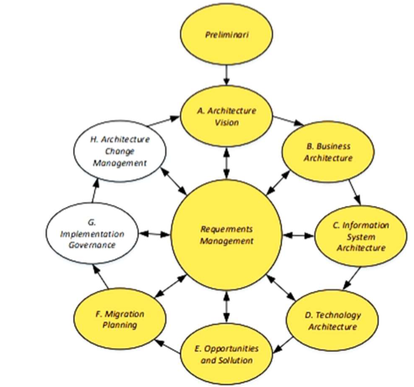
Figure 1. Adapted TOGAF ADM Cycle for SPMI Digitalization
at Universitas Ma'soem

The specific activities and outputs for each adapted phase are detailed as follows:
- Preliminary Phase: Defining the "Architecture Capability" by establishing principles derived from the university's vision of "Cageur, Bageur, Pinter". This phase determines the customized framework for the quality assurance digital transformation.
- Phase A (Architecture Vision): Formulating the high-level vision of an "Integrated Quality Assurance Information System (SIPJAMU)" and identifying key stakeholders (Rectorate, LPM, GKM, Auditors) involved in the PPEPP cycle.
- Phase B (Business Architecture): Modeling the transition from manual, paper-based audit processes (baseline) to a fully automated digital audit workflow (target) using BPMN 2.0 to eliminate process redundancies.
- Phase C (Information System Architecture):
- Data Architecture: Designing the Entity Relationship Diagram (ERD) to integrate scattered quality data (documents, audit findings, corrective actions) into a centralized database.
- Application Architecture: Designing the modular structure of SIPJAMU, including E-Document, E-AMI, and Executive Dashboard modules.
- Phase D (Technology Architecture): Defining the necessary infrastructure, including server specifications, cloud hosting requirements, and security protocols (SSL/Firewall) to ensure system reliability during accreditation periods.
- Phase E (Opportunities and Solutions): Conducting a Gap Analysis to compare the baseline and target architectures, identifying the strategic steps needed to bridge the digital divide in the quality assurance process.
- Phase F (Migration Planning): Developing a strategic 3-year roadmap for system implementation, prioritizing the digitalization of audit instruments in the first year

RESULTS AND DISCUSSION
Preliminary Phase
The Preliminary Phase serves as the conceptual foundation and the primary boundary for the entire enterprise architecture project. Rather than merely listing general guidelines, this phase establishes the Architecture Principles Catalog (Table 1), which acts as the definitive set of rules guiding all subsequent design decisions across the TOGAF ADM cycle. Based on the university's vision of "Cageur, Bageur, Pinter", these principles ensure that the IT transformation strictly aligns with the institution's strategic policies.

Table 1. Architecture Principles Catalog
Domain | Principle | Description and Rationale
Business | Business Conformity | Information systems must fully support the PPEPP cycle and BAN-PT/LAM Accreditation. There must be no deviation between the system and the University Quality Manual.
Data | Single Source of Truth | Quality data (lecturers, curriculum, grades) is managed centrally to avoid duplication and inconsistency between Study Programs, Faculties, and the University.
Application | Ease of Use | The application interface must be user-friendly to minimize the learning curve for both senior auditors and new staff.
Technology | Security & Reliability | The infrastructure must ensure data security (confidentiality of audit results) and system availability (uptime) of at least 99% during the audit period.

This catalog is not merely supporting information; it functions as an analytical tool that directly dictates the architectural solutions formulated in the subsequent phases:
- Business Conformity (Impacts Phase B - Business Architecture): This principle mandates that the target business processes must fully support the PPEPP cycle and BAN-PT/LAM Accreditation standards without deviation. Consequently, the BPMN design formulated in Phase B is strictly mapped to the workflows mandated by the University Quality Manual, ensuring absolute regulatory compliance.
- Single Source of Truth (Impacts Phase C - Data Architecture): To resolve the existing issue of data fragmentation, this principle forces the Data Architecture to centralize all quality records (e.g., lecturer data, curriculum, grades). This directly determines the Entity Relationship Diagram (ERD) design in Phase C, effectively eliminating data duplication and inconsistencies between Study Programs and the University level.
- Ease of Use (Impacts Phase C - Application Architecture): Recognizing the diverse technical proficiencies of the users, this principle requires the Application Architecture to prioritize intuitive interfaces. This directly shapes the UI/UX design requirements for the SIPJAMU modules in Phase C, aiming to minimize the learning curve for both senior auditors and new administrative staff.
- Security & Reliability (Impacts Phase D - Technology Architecture): Given the high confidentiality of audit findings and institutional performance data, this principle dictates stringent infrastructure requirements. It directly influences the technology selection in Phase D, justifying the necessity for HTTPS (SSL) protocols, firewalls, automated daily backups, and a cloud hosting environment that guarantees at least 99% uptime during critical audit periods.

Phase A: Architecture Vision
At this stage, the architectural vision is no longer formulated merely as a normative institutional goal; rather, it is defined as a measurable, operational solution to address the persistent issues of data fragmentation and manual audit inefficiencies. The architectural vision for this research is established as follows: "To realize an integrated digital ecosystem that automates the PPEPP quality cycle, centralizes the data flow of quality documents, and facilitates the real-time tracking of audit findings to enhance operational effectiveness and ensure the validity of accreditation data." This definition provides concrete success indicators for evaluating the alignment between the proposed information system and the university's business requirements.
To ensure that this vision accommodates the strategic interests of all involved parties, an in-depth stakeholder analysis was conducted. This analysis goes beyond merely mapping organizational roles; it identifies essential information needs and determines how these requirements are directly translated into architectural design decisions in the subsequent phases:
- Rector/Vice Rector (Sponsor) Strategic Interest: Requires visibility into institutional accountability, the monitoring of Key Performance Indicators (KPIs), and the overall accreditation readiness of the study programs.
- Design Impact: This requirement directly underpins the design of the Executive Dashboard (App-05) module within the application architecture (Phase C). This module is strategically designed to present real-time visualizations of audit score trends, thereby supporting data-driven decision-making by the university leadership.
- Head of LPM (Process Owner) Strategic Interest: Bears the primary responsibility for the seamless execution, continuous monitoring, and strict compliance of all stages within the PPEPP cycle.
- Design Impact: This operational need is translated into the business process redesign in Phase B. The target workflows are modeled using Business Process Model and Notation (BPMN) to incorporate automated notifications and centralized tracking of corrective action statuses (Open/Closed), effectively eliminating manual administrative bottlenecks.
- Quality Control Group/GKM (Key User) Strategic Interest: Requires a streamlined approach to implementing quality standards at the faculty/study program level, as well as practicality in compiling self-evaluation evidence.
- Design Impact: These user-centric needs directly influence the specifications of the E-Document (App-01) and E-Monev (App-04) modules. The system architecture includes version control features and intuitive interfaces to optimize the uploading of compliance evidence and the monitoring of daily academic activities.
- Internal Auditor (User) Strategic Interest: Requires an objective, efficient, and transparent auditing process, complete with seamless access to digital audit instruments and historical track records.
Design Impact: Technically, this requirement is realized through the development of the E-AMI (App-02) module in Phase C. This module facilitates a fully paperless environment by providing direct input forms for audit findings and automated scoring functionalities, thus relieving auditors from the burden of manual data recapitulation. Through this comprehensive mapping, the architectural vision guarantees that every technological and application component designed within this blueprint is firmly grounded in resolving the daily operational constraints faced by the stakeholders.

Phase B: Business Architecture
In this phase, a comprehensive redesign of the core business processes is undertaken, focusing primarily on the Internal Quality Audit (AMI) cycle, which serves as the critical evaluation mechanism of the institution. Guided by the "Business Conformity" principle established in the Preliminary Phase, this redesign ensures that every proposed digital workflow strictly adheres to the PPEPP cycle (Determination, Implementation, Evaluation, Control, and Improvement) mandated by the university's quality manual.
Rather than merely shifting from manual to digital formats, this phase conducts an in-depth comparative analysis to bridge the gap between the existing operational constraints (baseline) and the envisioned integrated system (target):
- Baseline Condition (Current): The existing AMI process is heavily fragmented. Audit scheduling and instrument distribution rely on manual tracking and physical documents or decentralized emails. Consequently, the "Evaluation" phase suffers from prolonged data collection, and the "Control" phase is often delayed because corrective actions are difficult to monitor systematically.
- Target Condition (Proposed): The redesigned business architecture introduces a unified, automated workflow. It enforces a standardized sequence where data inputs from the Auditee seamlessly transition to the Auditor and subsequently to the LPM without media discontinuity.
To visualize this transformation, Figure 2 presents the Business Process Model and Notation (BPMN) diagram of the target digital AMI process. This target architecture reflects significant improvements in effectiveness, efficiency, and quality control across the PPEPP cycle through the following streamlined mechanisms:
- Automated Planning & Notification (Supporting Determination/Implementation): The system automates audit scheduling and auditor assignments with real-time notifications, eliminating administrative delays and ensuring strict timeline adherence.
- Integrated Execution & Desk Evaluation (Supporting Evaluation): Auditees submit digital instruments and evidence into a centralized repository. This allows auditors to conduct remote desk evaluations, saving visitation time and preventing document loss.
- Real-Time Visitation & Scoring (Supporting Evaluation): Auditors input categorized findings directly into the system during visitations. Automated scoring logic prevents calculation errors and instantly generates audit minutes.
- Data-Driven Control & Continuous Improvement (Supporting Control & Improvement): The system aggregates audit findings for Management Review Meetings (RTM) and tracks corrective actions in real-time (Open/Closed). This ensures transparent measurement of continuous improvement and maintains accountability.

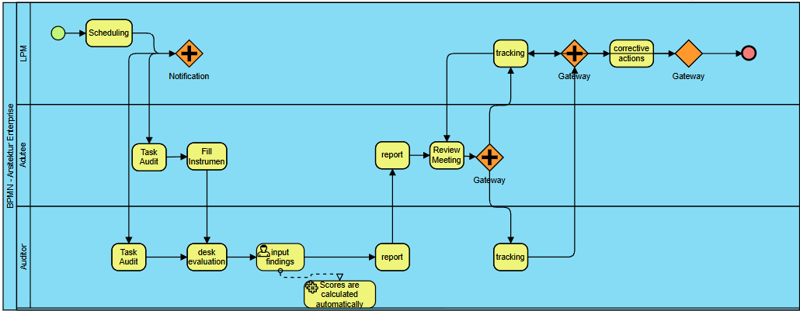
Figure 2. BPMN of the Target Business Process for the Digital Internal
Quality Audit (AMI)

Phase C: Information System Architecture
This phase focuses on the design of the data structure and application modules required to support the aforementioned business processes.
- Data Architecture
The data architecture is designed to ensure data integrity and the relationships among quality-related data. The following is the Entity Relationship Diagram (ERD) illustrating the structure of the system database.
- Application Architecture
Application Architecture: Based on the target business processes, the development of the Integrated Quality Assurance Information System (SIPJAMU) is proposed, containing the modules listed in Table 2.

Table 2. Application Module Design
Module Code | Module Name | Primary Function | User
App-01 | E-Document | Repository for documents (Policies, Manuals, Standards, SOPs) with version control features. | Admin LPM
App-02 | E-AMI | Audit cycle management: Scheduling, Self-Evaluation filling, Desk Evaluation, Finding Input, Scoring. | Audior, Auditee, LPM
App-03 | E-Survey | Satisfaction surveys for students, lecturers, staff, and graduates online with automatic statistical analysis. | Civitas Academica
App-04 | E-Monev | Daily learning monitoring (lecturer attendance, RPS compliance) integrated with the Academic Information System (SIAKAD). | GKM, Prodi
App-05 | Dashboard | Visualization of Key Performance Indicators (KPIs), audit score trends, and study program accreditation status for leadership. | Rectorat

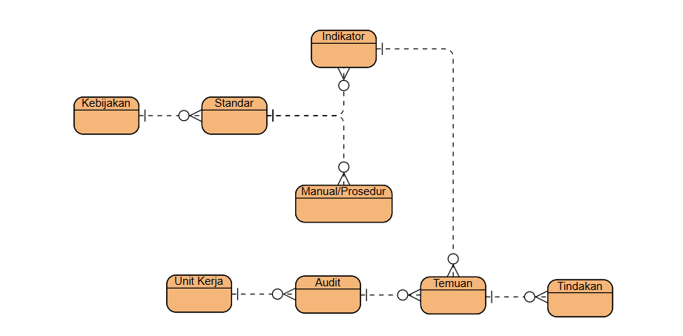
Figure 3. Enity Relationship Diagram (ERD)

Phase D: Technology Architecture
In this phase, the technology architecture is designed not merely as a list of software and hardware specifications, but as a comprehensive deployment topology that guarantees the system's performance, security, and high availability. Guided by the "Security & Reliability" principle established in the Preliminary Phase, the infrastructure is engineered to support the rigorous demands of the SIPJAMU modules.
Figure 4 illustrates the proposed technological topology, detailing the relationships between key components, access flows, and security layers:
- Client Access Flow: Users access the responsive web application via standard browsers over the public internet, directed to the university's central domain.
- Security Layer: A Web Application Firewall (WAF) secures the perimeter. All data transmissions are strictly encrypted via HTTPS (SSL) to protect confidential audit findings from unauthorized interception.
- Application/Web Server Layer: Built on robust frameworks (e.g., PHP Laravel or Python Django), the core business logic is hosted on a centrally managed VPS or Cloud environment. This grants administrators full control over resource allocation during peak audit (AMI) periods.
- Database Layer: Utilizing MySQL or PostgreSQL, the database communicates with the application server exclusively through a private, isolated virtual network, preventing direct public internet exposure.
- System Availability: To guarantee 99% uptime and enable disaster recovery, the architecture employs automated daily backups, ensuring no critical accreditation data is lost during hardware failures.
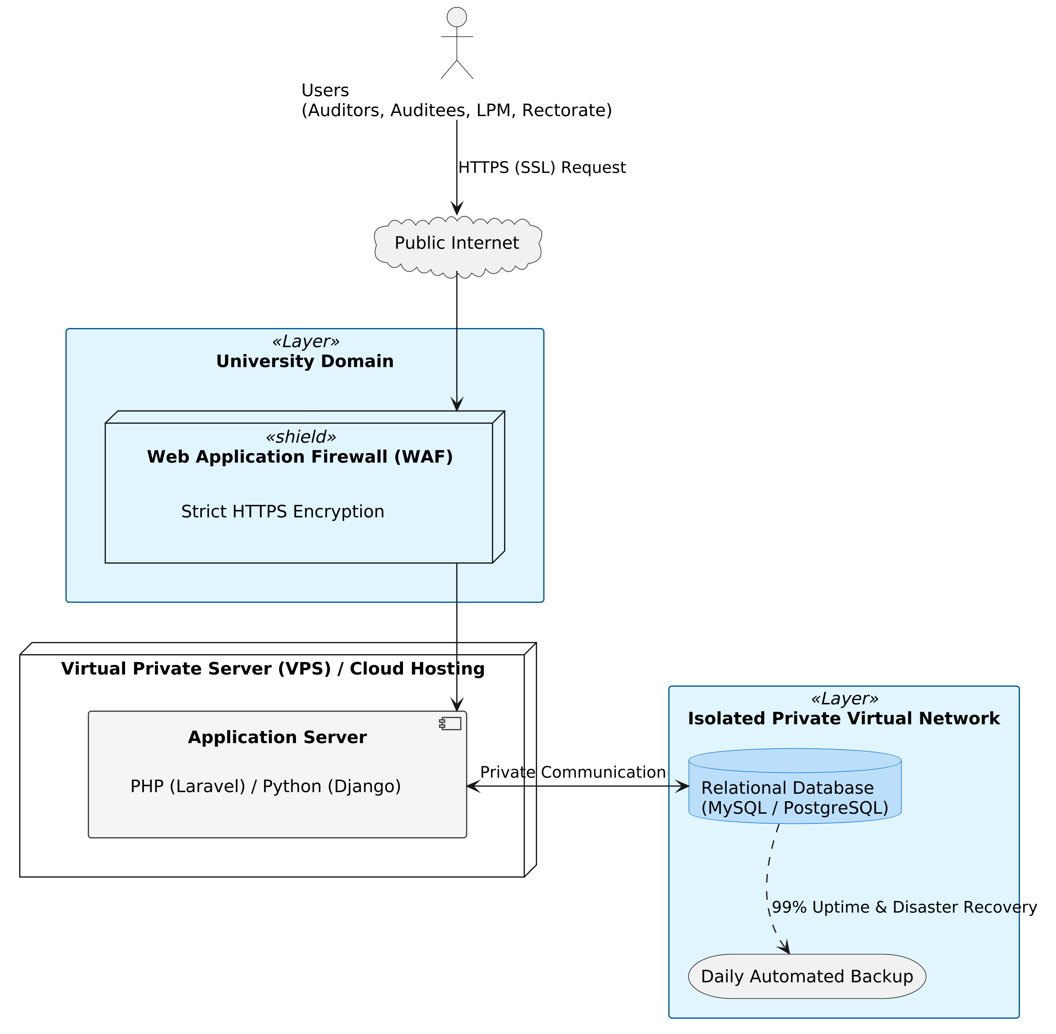
Figure 4. Technology Architecture Topology for SIPJAMU

Phase E: Opportunities and Solutions (Gap Analysis)
A gap analysis was conducted to compare baseline and target conditions and to formulate solution strategies.
Table 3. Gap Analysis Matrix
Domain | Baseline Condition (Current) | Target Condition (Expected) | Proposed Solution
Business | Paper-based audit processes; slow data recapitulation; difficult to track corrective action follow-ups. | Fully automated audit workflows with real-time tracking of corrective actions across the PPEPP control phase. | Implement the redesigned BPMN workflows, enforcing standardized digital AMI cycles and automated notifications.
Data | Quality data is scattered across personal laptops and decentralized cloud drives (Google Drive), leading to high redundancy. | A "Single Source of Truth" where all quality metrics are relationally linked to university policies and audit findings. | Centralize all quality records into a unified relational database schema (as designed in the ERD).
Aplication | Heavy reliance on physical documents and siloed desktop applications (e.g., spreadsheets) lacking integration. | An integrated suite of web-based modules catering to specific stakeholder needs (Auditors, Auditees, Executives). | Develop and deploy the SIPJAMU ecosystem, encompassing E-Document, E-AMI, E-Survey, E-Monev, and Dashboard modules.
Technology | Lack of dedicated, secure, and centrally managed hosting specifically for quality assurance data. | Secure, highly available infrastructure ensuring data confidentiality and at least 99% uptime during audit periods. | Deploy Cloud/VPS hosting secured by a Web Application Firewall (WAF), HTTPS (SSL), and automated daily backup protocols.

Phase F: Migration Planning
This phase outlines a strategic 3-year roadmap to ensure a structured and smooth transition from the manual baseline to the target digital ecosystem. Rather than merely listing chronological activities, the prioritization within this roadmap is analytically driven by three core criteria: inter-module functional dependencies, implementation risk mitigation, and organizational readiness.

Table 4. LPM Information System Implementation Roadmap
Year | Primary Focus | Key Activities
Year 1 | Foundation & Document Digitalization | Server infrastructure procurement; Development of E-Document & E-Survey Modules; Migration of manual documents to digital; Initial socialization to work units.
Year 2 | Audit Automation (AMI) | Development of E-AMI Module; API Integration with SIAKAD (Lecturer/Student Data); Pilot Project of Digital AMI in 2 Study Programs; Auditor training/certification for the new system.
Year 3 | Integration & Advanced Analytics | Full implementation of E-AMI across the University; Development of Executive Dashboard & Analytics; Integration of reporting to PDDIKTI/SPMI Kemdiktisaintek; Post-implementation evaluation.

CONCLUSION
This research has successfully designed a comprehensive Enterprise Architecture blueprint for the Internal Quality Assurance System (SPMI) using the TOGAF ADM method. Moving beyond a descriptive technical summary, the primary scientific contribution of this study lies in its methodological alignment: it successfully maps the complex, regulatory-driven PPEPP cycle (Determination, Implementation, Evaluation, Control, and Improvement) into a structured digital enterprise framework. Unlike studies limited to a single standard [15] , a single architecture layer [16] , or system development without an architecture framework [14], [18] this blueprint covers the entire cycle and links audit findings to executive monitoring. By formulating the Integrated Quality Assurance Information System (SIPJAMU), this research provides a proven conceptual model that transforms fragmented, manual audit procedures into a centralized, real-time data ecosystem. This blueprint serves as a strategic and scalable reference for higher education institutions seeking to shift their quality assurance paradigm from basic regulatory compliance to a data-driven quality culture.
Despite these contributions, this study acknowledges certain limitations. First, the proposed architecture currently remains at the conceptual blueprint and prototyping stage; it has not yet undergone full-scale software deployment and empirical usability testing across all faculties. Second, as a qualitative case study confined to a single institution, the specific application modules and technological topology recommended may require contextual adjustments before being adopted by universities with different operational scales or varying levels of existing IT maturity.
To address these limitations and advance the domain of educational IT governance, future research should prioritize the physical implementation and empirical evaluation of the SIPJAMU ecosystem. Furthermore, as digital transformation in higher education matures, future studies are highly encouraged to explore the integration of Artificial Intelligence (AI) within this established enterprise architecture. Specifically, future developmental research could investigate how AI applications and machine learning algorithms can be embedded into the quality assurance system to automate document evaluation, predict accreditation risks, and provide intelligent, predictive decision support for university leadership.

BIBLIOGRAPHY
[1] L. M. Castro Benavides, J. A. Tamayo Arias, M. D. Arango Serna, J. W. Branch Bedoya, and D. Burgos, “Digital Transformation in Higher Education Institutions: A Systematic Literature Review,” Sensors 2020, Vol. 20, Page 3291, vol. 20, no. 11, p. 3291, Jun. 2020, doi: 10.3390/s20113291.
[2] Kemdiktisaintek, Peraturan Menteri Pendidikan Tinggi, Sains, dan Teknologi Nomor 39 Tahun 2025. 2025, p. 6. [Online]. Available: https://peraturan.bpk.go.id/Details/333967/permendikti-saintek-no-39-tahun-2025
[3] Universitas Ma’soem, “Visi Misi.” Accessed: Jan. 06, 2026. [Online]. Available: https://masoemuniversity.ac.id/tentang-kami/visi-misi.php
[4] M. Furqon and N. I. Yusman, “Perencanaan Strategis Sistem Informasi Menggunakan Metode Ward and Peppard di Lembaga Penjaminan Mutu Universitas Ma’soem,” INTERNAL (Information System Journal), vol. 8, no. 1, pp. 55–69, 2025, doi: https://doi.org/10.32627/internal.v8i1.1454.
[5] L. Najwa, M. Iqbbal, and M. Aryani, “Manajmen implementasi Sistem Penjaminan Mutu Internal di Perguruan Tinggi,” Jurnal Visionary : Penelitian dan Pengembangan dibidang Administrasi Pendidikan, vol. 11, no. April, pp. 72–77, 2023.
[6] M. A. Ramadhan and R. Setyaningsih, “Implementasi Sistem Penjaminan Mutu Internal (SPMI) di Perguruan Tinggi,” Jurnal Kependidikan Islan, vol. 15, no. 1, pp. 23–33, 2025, Accessed: Jan. 07, 2026. [Online]. Available: https://scholar.google.com/citations?view_op=view_citation&hl=en&user=ZUp5sAkAAAAJ&citation_for_view=ZUp5sAkAAAAJ:_Qo2XoVZTnwC
[7] M. Suti, Muh. Z. Syahdi, and D. D., “Tata Kelola Perguruan Tinggi dalam Era Teknologi Informasi dan Digitalisasi,” JEMMA (Journal of Economic, Management and Accounting), vol. 3, no. 2, p. 203, 2020, doi: 10.35914/jemma.v3i2.635.
[8] T. O. Group, The TOGAF®Standard, Version 9.2 - A Pocket Guide. Van Haren Publishing, 2018. [Online]. Available: https://books.google.co.id/books?id=bVgdEQAAQBAJ
[9] A. Desfiandi, F. Santi, N. Sari, and R. Herwanto, “Designing an Enterprise Architecture for Holistic Governance in Private Higher Education Institutions : A Strategic Approach for Enhanced Quality and Value Creation,” International Journal of Artificial Intelegence Research, vol. 8, no. 1, pp. 1–10, 2024.
[10] P. Febrianto, A. A. N. Fajrillah, and W. Febriyani, “Enterprise Architecture for Education: A TOGAF Approach to Achieve Digital Transformation and Optimal Performance (A Case Study of Shared Service Function),” Syntax Literate: Jurnal Ilmiah Indonesia, vol. 9, no. February, pp. 4–6, 2024.
[11] D. A. Oktaviani, M. F. Nugraha, and T. Trianto, “Perencanaan Arsitektur Sistem Informasi Sekolah Menggunakan Metode Togaf di SMK PGRI 35,” Jurnal Dimamu, vol. 3, no. 2, pp. 142–155, 2024.
[12] R. Rinaldi, R. Farta Wijaya, D. Nasution, and A. Putera Utama Siahaan, “Enterprise Architecture Using TOGAF ADM To Support Smart Campus At STAI Raudhatul Akmal,” Informatika dan Sains, vol. 14, no. 04, pp. 619–630, 2024, doi: 10.54209/infosains.v14i04.
[13] J. Cevin, D. Gultom, and L. Hermawan, “Digitalisasi Sistem Penjaminan Mutu Internal (SPMI) untuk Institusi Pendidikan Berbasis Website,” MDP Student Conference, vol. 4, pp. 313–320, 2025, doi: 10.35957/mdp-sc.v4i1.11183.
[14] M. A. Assidiq, L. Hadjaratie, and N. Pakaya, “Rancang Bangun Sistem Informasi Audit Mutu Internal Di Fakultas Teknik Universitas Negeri Gorontalo Berbasi Web,” Diffusion Journal of System and Information Technology, vol. 4, no. 1, pp. 1–7, 2024.
[15] S. Widiantoro, Kerangka Arsitektur Enterprise Berbasis TOGAF untuk Standar Proses Persiapan Pembelajaran Perguruan Tinggi.
[16] P. H.M.C., J. P.M., and W. M.K, “Using the Open Group Architecture Framework (TOGAF) for Quality Assurance in Higher Education Teaching and Learning,” Mar. 2021, doi: 10.2139/SSRN.3808691.
[17] W. Wiyana and W. W. Winarno, “Sistem Panjaminan Mutu Pendidikan Dengan TOGAF ADM Untuk Sekolah Menengah Kejuruan,” Register: Jurnal Ilmiah Teknologi Sistem Informasi, vol. 1, no. 1, pp. 7–14, Nov. 2015, doi: 10.26594/REGISTER.V1I1.401.
[18] I. Alhassan, D. Sammon, and M. Daly, “Data governance activities: an analysis of the literature,” J. Decis. Syst., vol. 25, no. sup1, pp. 64–75, 2016, doi: 10.1080/12460125.2016.1187397.
[19] J. W. Creswell and Creswell. J David, Research Design: Qualitative, Quantitative, and Mixed Methods Approaches, 5th ed. SAGE Publications, 2017.
[20] R. K. Yin, “Case Study Research and Applications. Sixth Edition,” 2018.
[21] N. Shabrina Meutia, E. Sulistiyani, R. Putri Nourma Budiarti, and R. Sari, “Enterprise Architecture Framework in Higher Education: Systematic Literature Review,” Applied Technology and Computing Science Journal, vol. 5, pp. 33–39, Feb. 2022, doi: 10.33086/atcsj.v5i2.3751.
[22] I. Etikan, S. A. Musa, and R. S. Alkassim, “Comparison of Convenience Sampling and Purposive Sampling,” American Journal of Theoretical and Applied Statistics, vol. 5, no. 1, pp. 1–4, 2015, doi: 10.11648/j.ajtas.20160501.11.
[23] D. Magaldi and M. Berler, “Semi-structured Interviews,” in Encyclopedia of Personality and Individual Differences, T. K. Zeigler-Hill Virgil and Shackelford, Ed., Cham: Springer International Publishing, 2020, pp. 4825–4830. doi: 10.1007/978-3-319-24612-3_857.
[24] A. Queirós, D. Faria, and F. Almeida, “Strengths and Limitations of Qualitative and Quantitative Research Methods,” European Journal of Education Studies, vol. 2, 2017, doi: 10.5281/zenodo.887089.
[25] N. Carter, D. Bryant-Lukosius, A. Dicenso, J. Blythe, and A. J. Neville, “The use of triangulation in qualitative research,” Oncol. Nurs. Forum, vol. 41, no. 5, pp. 545–547, Sep. 2014, doi: 10.1188/14.ONF.545-547.
[26] T. O.Nyumba, K. Wilson, C. J. Derrick, and N. Mukherjee, “The use of focus group discussion methodology: Insights from two decades of application in conservation,” Methods Ecol. Evol., vol. 9, no. 1, pp. 20–32, Jan. 2018, doi: 10.1111/2041-210X.12860.

